Clothes/He’s wearing/She’s wearing

Name: ­­____________

Spongebob is wearing a white shirt.

He’s ____________ brown ____________.

________ wearing black ______________ and __________ socks.

Patrick ___ ____________ green and ____________ shorts.

He’s _________ wearing a shirt.

Squidward ____ ____________ a brown _______________.

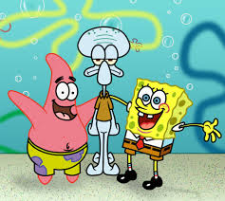

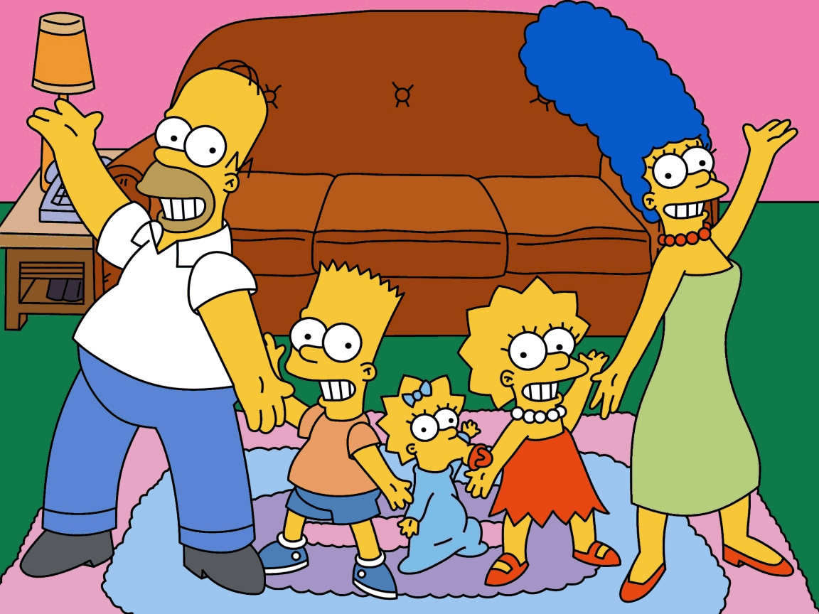

Lisa is wearing ______ ___________________ dress. ________ wearing orange _____________________.

Marge _____ _______________ a _____________ _______________. She’s __________________

orange ________________.

Homer is wearing a white t-shirt. He’s wearing blue __________________. He’s _______________ __________ shoes.

Bart ____ __________________ an ________________ t-shirt. ________ wearing ___________ shorts and blue __________.

Maggie is _____________________ ____ blue _________________. She’s not _________________ shoes.