


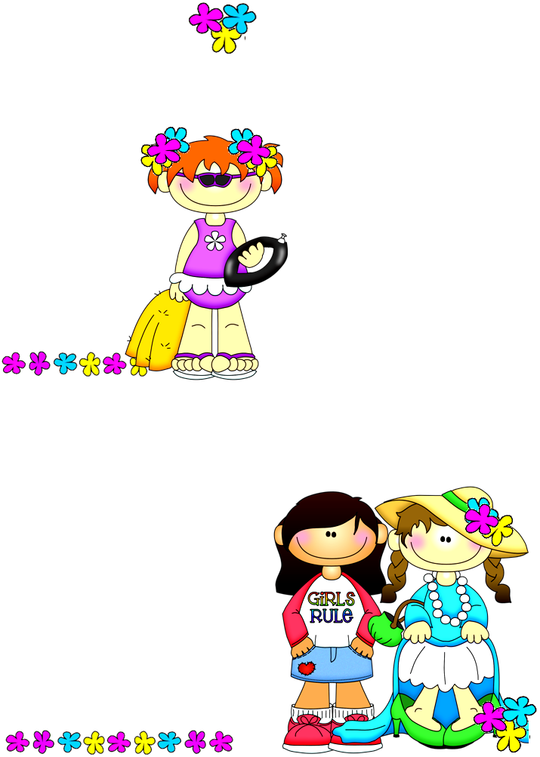
Choose the correct one
I have got – has got a little puppy.
Susan have got – has got a sister.
My grandfather have got – has got a horse.
We have got – has got a big house.
Sue’s father have got – has got gray hair.
Ashley and Arthur have got – has got black bicycles.
Derek have got – has got dark brown eyes.
My mother have got – has got a long red dress.
They have got – has got a lovely garden.
Our teacher have got – has got colorful hats.
The pirates have got – has got amazing treasures.
Gina and her sister have got – has got long black hair.
I have got – has got lots of books.
She have got – has got a big nose.
Fill in the blanks with “have got–has got / haven’t got–hasn’t got”
I ------------ anything to wear for the party tonight.
My sister ------------ dozens of dolls.
The kid ------------ freckles on his nose.
The policeman ------------ a gun.
The lady ------------ a ticket for the concert. She can’t go to the concert.
“------- you ----- a car?” “No, I --------.”
We ------------ enough food for the guests. We should buy something.
We ------------ enough time to finish this work. Do not worry about it.
We ------------ a vase for the flowers. They will die soon.
My father ------------ a black suit.
“-------- she ----- a swim suit?” “Yes, she ----------.”
Susan ------------ any money.
The bodyguards ------------ long black hair.
I ------------ reading books in my bookshelf.
My little brother ------------ any teeth.
The ladies ------------ wonderful dresses and jewelries.
We ------------ any eggs to make omelets.
They ------------ a big house near the river.
I ------------ a bikini to wear this summer. I have to buy one.
“------- you ------ any brothers or sisters?” “Yes, I ------------ a brother and a sister.”
Possessives
have got - has got

Ask and Answer.
Have you got a car? – Yes, I have got a car. ** you/car/ + **
---------------------------------------------------- **she/blue eyes/ - **
--------------------------------------------------- **they/big house / + **
------------------------------------------------------- **it/long tail/ + **
---------------------------------------------------------- **he/cat/ - **
------------------------------------------------------ **they/money/ + **
------------------------------------------------ **she/beautiful dress/ + **
--------------------------------------------------------- **he/son / + **
------------------------------------------------------- **you/sister / - **
--------------------------------------------------- **they/big house / + **
---------------------------------------------------- **you/swim suit / + **

Choose the correct one
I have got – has got a little puppy.
Susan have got – has got a sister.
My grandfather have got – has got a horse.
We have got – has got a big house.
Sue’s father have got – has got gray hair.
Ashley and Arthur have got – has got black bicycles.
Derek have got – has got dark brown eyes.
My mother have got – has got a long red dress.
They have got – has got a lovely garden.
Our teacher have got – has got colorful hats.
The pirates have got – has got amazing treasures.
Gina and her sister have got – has got long black hair.
I have got – has got lots of books.
She have got – has got a big nose.
Fill in the blanks with “have got–has got / haven’t got–hasn’t got”
I ------------ anything to wear for the party tonight.
My sister ------------ dozens of dolls.
The kid ------------ freckles on his nose.
The policeman ------------ a gun.
The lady ------------ a ticket for the concert. She can’t go to the concert.
“------- you ----- a car?” “No, I --------.”
We ------------ enough food for the guests. We should buy something.
We ------------ enough time to finish this work. Do not worry about it.
We ------------ a vase for the flowers. They will die soon.
My father ------------ a black suit.
“-------- she ----- a swim suit?” “Yes, she ----------.”
Susan ------------ any money.
The bodyguards ------------ long black hair.
I ------------ reading books in my bookshelf.
My little brother ------------ any teeth.
The ladies ------------ wonderful dresses and jewelries.
We ------------ any eggs to make omelets.
They ------------ a big house near the river.
I ------------ a bikini to wear this summer. I have to buy one.
“------- you ------ any brothers or sisters?” “Yes, I ------------ a brother and a sister.”
Possessives
have got - has got

Ask and Answer.
Have you got a car? – Yes, I have got a car. ** you/car/ + **
---------------------------------------------------- **she/blue eyes/ - **
--------------------------------------------------- **they/big house / + **
------------------------------------------------------- **it/long tail/ + **
---------------------------------------------------------- **he/cat/ - **
------------------------------------------------------ **they/money/ + **
------------------------------------------------ **she/beautiful dress/ + **
--------------------------------------------------------- **he/son / + **
------------------------------------------------------- **you/sister / - **
--------------------------------------------------- **they/big house / + **
---------------------------------------------------- **you/swim suit / + **

